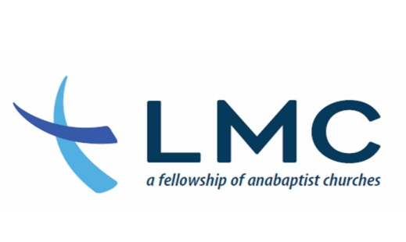
Angelus: A Call to Prayer
March, 2019

- Honduras: Keep Bobby and Amanda Peoples in your prayers that they will continually be encouraged, seeing God’s love in their work with children and youth.

- Southeast Asia: Pray that Timothy and Madison* might be steadfast, immovable, and always abounding in the work of the Lord, knowing that their labor is not in vain.

- Global: Jonathan Bornman continues to have many opportunities to build bridges between Muslims and Christians. Pray for his Muslim friends who might be interested in the gospel.

- Pray for Omar Guzman as he is traveling every weekend in March. Ask the Lord to watch over his going out and his coming in.

- Please pray for the Conference Executive Council as they meet on Friday, the 10th.

- Join the Garifuna Church of Manhattan in praising God for his 12 years faithfulness.

- North Africa: Nicholas* desires God’s wisdom and love in all of his relationships with fellow students and language teachers. Pray that he might have a clear mind to focus on his studies and friendships with others.

- Pray for boldness among new leaders who start neighborhood churches in and around Lancaster to stay hospitable in the face of challenges.

- Pray for the STEP students as they meet for class today.
- The Lancaster Mennonite High Campus Chorale spring concert season begins on March 10. Pray that God may be glorified and that students and listeners are blessed in each concert. Pray also for safety as students travel to the different locations.
- Albania: Pray for clarity for Sonya Harnish regarding further ministry involvements and the courage to walk forward after being in a season of uncertainty on how God would best have her invest her time. Pray for the ability to listen well and for wisdom and courage in conversations as she continues to build friendships with locals and foreigners in the Korça area.

- Parent-teacher conferences are being held March 14 and 15 at all Lancaster Mennonite School campuses. These conferences provide good opportunities for discussions on the best way to enable each student to learn to the best of their ability. Pray for parents and faculty as they meet and also for the students that will lead some of the conferences.

- Please pray for the Credentialing Commission as they meet today and interact with pastors.

- Pray for Yellow Creek Mennonite Church as they go through some staff transitions. Praise for new members received and the gifts they bring for our ministries.

- Pray for the Leadership Assembly gathering at Petra Church.

- Pray for the Celebration of Church Life taking place today at Petra Church. Pray the His Kingdom come and His will be done and that we will hear what the Spirit is saying to the Church in this season.

- U.S. Ask the Lord to show Marty and Glenna Sollenberger glimpses of the fruit of their labors in computer support and library services with Wycliffe where they have been serving for many years.

- Thailand: Pray for Hannah Zimmerman as she continues to serve in her role of Third Culture Kid (TCK) trainer. She will give leadership to the children’s ministry at the Southeast Asia workers’ retreat, March 26–31. Pray for good relationships with the children, youth, and parents.

- The last quarter of this school year at Lancaster Mennonite School begins soon. Pray that students, faculty and staff will continue to work with energy and enthusiasm toward the completion of another good year

- Hong Kong: Pray for Glen and June Kauffman, non-resident workers to Hong Kong, as they nurture prayer-filled relationships with Mennonite churches in East Asia

- Costa Rica: Austin Zuercher appreciates your prayers as he leads teams in the VidaNet training in Costa Rica, and as he travels throughout Central America encouraging church leaders.

- Cambodia: Ryan and Bethany Umble, and their family, will be completing their assignment and returning to the U.S. this summer. Pray for them as they hand off their responsibilities and train others to pick up their roles. Ask for peace for the whole family during this time of saying goodbye and transitioning to the U.S.

- Wales, U.K.: Pray that Alan and Carol Wert can be a blessing to all they meet in their various engagements through football, meals shared around the table, teaching and preaching, school and work. Pray for their daughter, Cerys, as she finishes high school in the next couple of months and makes choices about her future.

- Please lift prayers of thanksgiving for the many dedicated team members from across Landis Communities who are serving those age 55 and above. They are living out the guiding values of Joy, Compassion, Integrity, Stewardship and Community. Serving as “Jesus Christ In Street Clothes” to residents and clients.

- Pray for Community Mennonite Fellowship as they seek a lead pastor.

- South Asia: Pray for Jack and Julia*, and their children, as they near the end of their sabbatical and as they prepare to continue their ministry overseas.

- U.S.: Ask God to guide Michael Clancy as he works with community development in Lebanon City, Pa.

- Belize: Nathanael and Spring Davis serve in Belize. Pray for Nathanael as he pastors a church for the Deaf community in Belize, and for Spring in a variety of roles as mother, nurse, midwife, and friend. Ask that relationships will lead to deeper friendships and opportunities to share Jesus as Lord and Savior.

- Pray for the Conference Related Ministry seminar taking place at Garden Spot Village today.

- Pray for the marriage enrichment event taking place at Community Mennonite Fellowship in early April.

- PRAISE the LORD for His faithfulness to LMC. His love endures forever!
*Name(s) changed or last name(s) omitted for security reasons.

