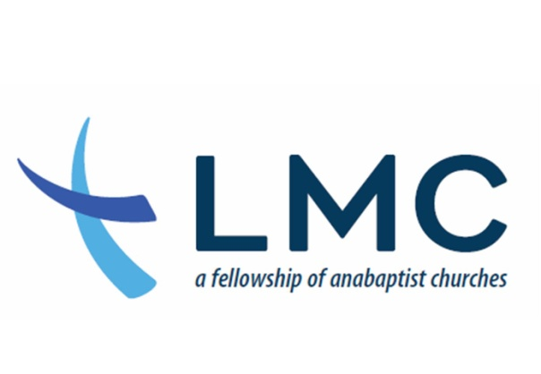
Fall Leadership Assembly

Topic: Discerning God’s Mission and Calling for LMC

Date: Saturday, September 28, 2019

Time: 8:30 -3:30 pm

Resourcing Provided by: Conrad Kanagy, LMC Resource Staff and Lead Pastor at
Elizabethtown Mennonite Church

Who should attend: bishops, pastors, elders, deacons, lay leaders, leadership
team members

Location: Elizabethtown Mennonite Church, 300 S. Spruce Street, Elizabethtown PA

Cost: Free!

Proposed Schedule
8:30 Registration
9:00 Welcome, Worship, Dwelling in the Word
10:00 What is the Spirit revealing? A historical, theological and sociological review.
11:00 Break
11:15 Prayer and Proposed LMC Mission Supporting Commitments Document
12:30 Lunch
1:45 Round table engagement about mission and supporting commitments
document
2:45 Congregational work: What are 2-3 action steps congregations can
implement immediately?
3:20 Closing remarks and prayer

Please register here: https://www.eventbrite.com/e/lmc-fall-leadership-assembly-tickets-62642845437

Notes:
- If you are unable to attend in person, please contact Marcia at mmylin@lmcchurches.org for information on how to connect via zoom
- Translation is available. Please contact Marcia at mmylin@lmcchurches.org

